**Lesson 07 Demo 03**

**Optimizing Test Planning for Healthcare Analytics Platform Using GenAI**

**Objective:** To streamline test planning for the healthcare analytics platform using ChatGPT for enhanced efficiency, accuracy, and regulatory compliance

**Tools required:** ChatGPT 4

**Prerequisites:** None

Steps to be followed:

1. Define the scope of testing using ChatGPT
2. Define testing objectives and strategies using ChatGPT
3. Determine testing tools and assess industry standard compliance using ChatGPT

**Note:** Please be advised that ChatGPT, as an artificial intelligence tool, can produce varied outputs even when presented with similar prompts.

**Step 1:** **Define the scope of testing using ChatGPT**

* 1. Browse to the **https://chat.openai.com** website and log in to your account  
       
     A screenshot of a computer

     Description automatically generated

|  |
| --- |
| **Note**: Sign up if you do not have an account |

* 1. Provide project details and specify the scope of testing, including dynamic updates in data analytics, UI responsiveness, and API security:  
     **The following are the project details for your reference:**  
     **Project details:**

**Project name: MediTrack**

**Description: A healthcare analytics platform providing real-time insights into patient data**

**Scope of testing:**

**Dynamic updates in data analytics**

**UI responsiveness**

**API security**

**Stakeholders: Development team, QA team, Project manager, Healthcare providers**

**Timeline: 4 months**

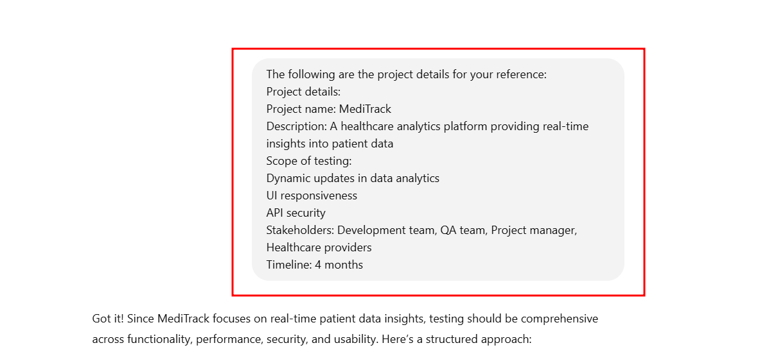

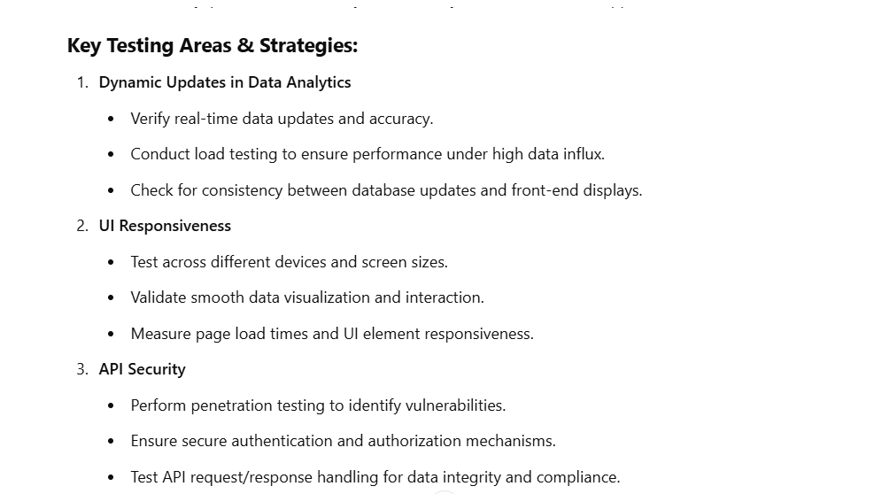  
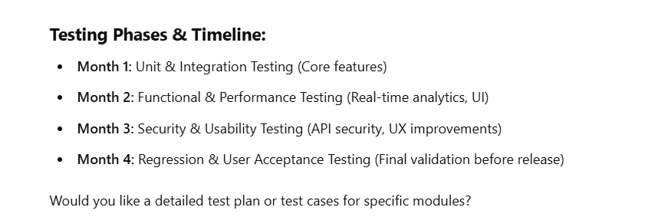

* 1. Use the following prompt to specify in detail about the project, as shown in the screenshot below:  
     **Our project is a healthcare analytics platform called 'MediTrack' that provides real-time insights into patient data for healthcare providers. We need to ensure thorough testing across three key areas:**

**Dynamic updates in data analytics: How can we ensure that the platform accurately updates and analyzes patient data in real-time to provide actionable insights for healthcare professionals?**

**UI responsiveness: What strategies should we employ to test the responsiveness of the user interface across different devices and screen sizes, considering healthcare providers may access the platform on various devices?**

**API security: How can we verify that the APIs used for data integration and exchange are secure and protected against potential security threats or data breaches?**

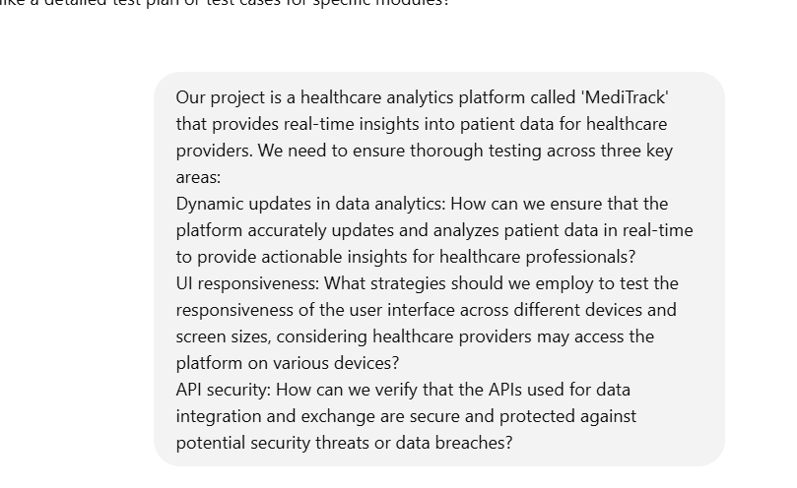  


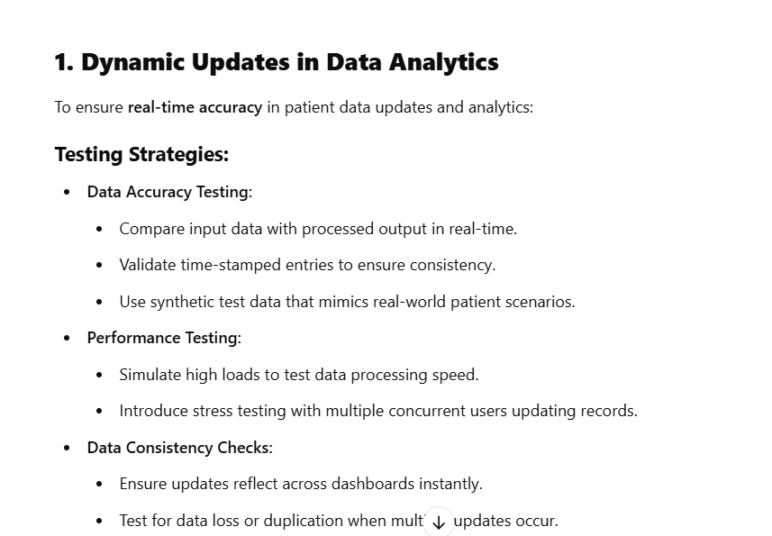

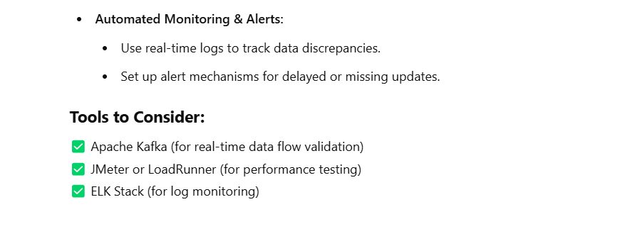

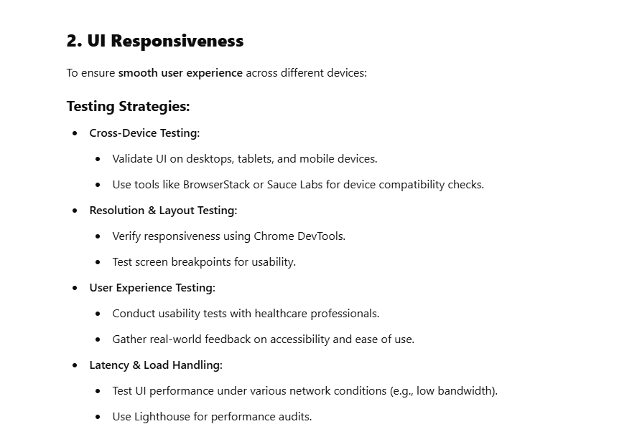



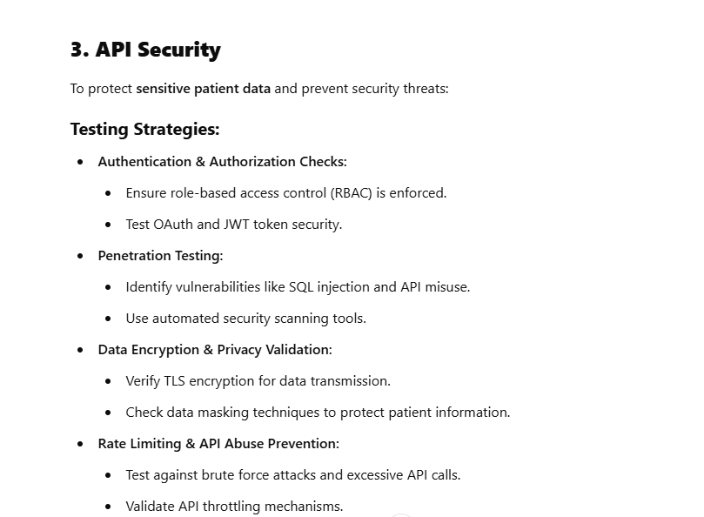

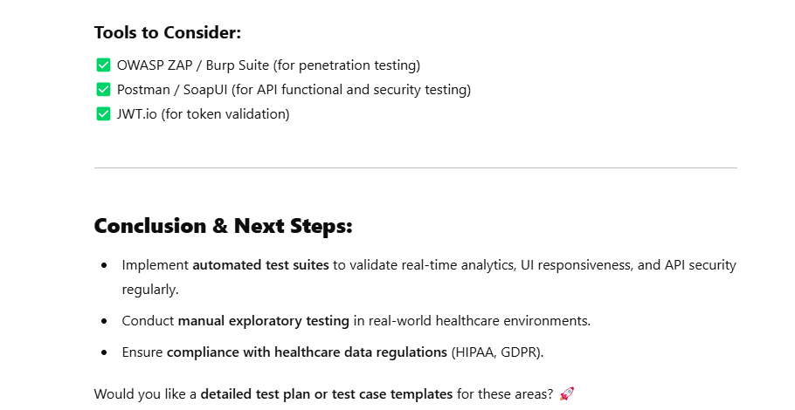

**Step 2:** **Define testing objectives and strategies using ChatGPT**

* 1. Establish measurable objectives for testing using the following prompt, as shown in the screenshot below:  
     **Considering the project goals and requirements, what specific measurable objectives should we set for the testing phase? Examples could include uptime, response times, and user interaction metrics. Please provide measurable targets for each objective.**  
       
     

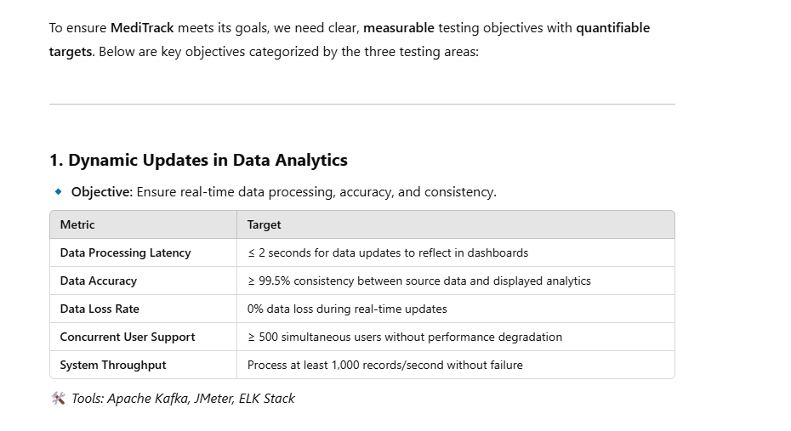

* 1. Use the following prompt to ensure that the objectives align with project goals and stakeholder expectations, as shown in the screenshot below:  
     **Before finalizing the testing objectives, let us ensure they align with the overall project goals and meet stakeholder expectations. Are there any additional objectives or adjustments needed to ensure alignment with project objectives and stakeholder expectations?**

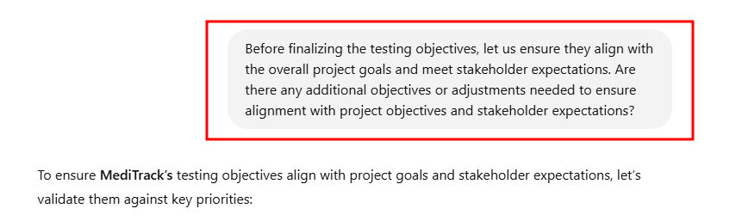

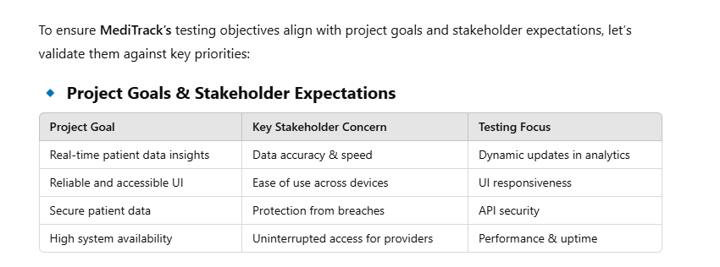

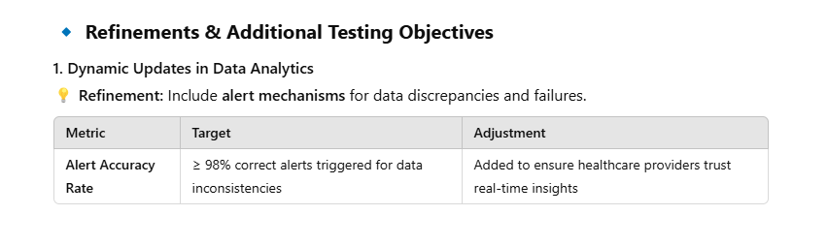 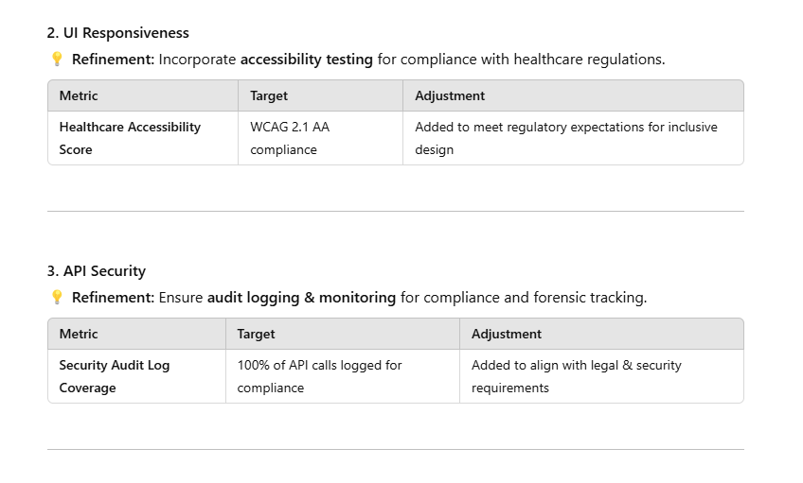

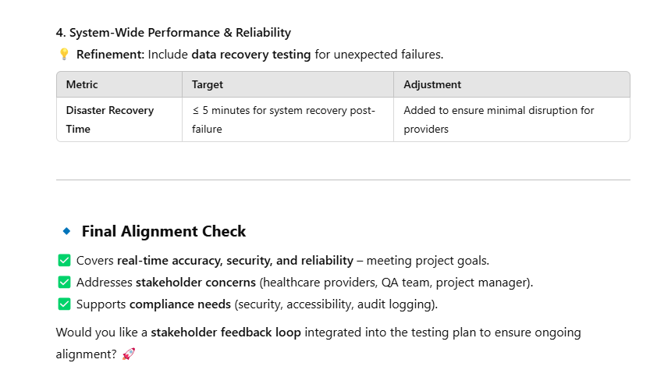

* 1. Use the following prompt to define the testing strategies, as shown in the screenshot below:  
     **Considering the defined scope and objectives, what testing strategies would you recommend for ensuring comprehensive coverage and efficient testing?**  
       
     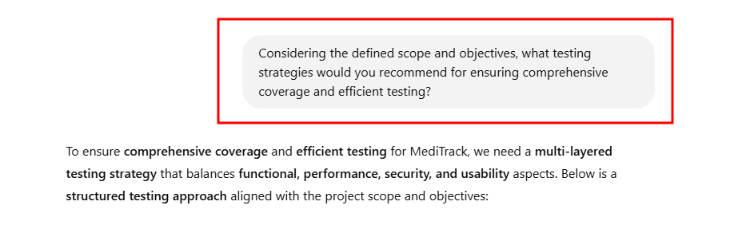

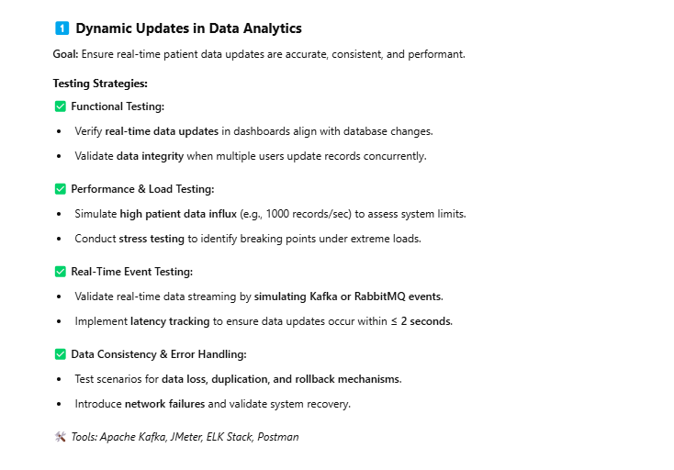

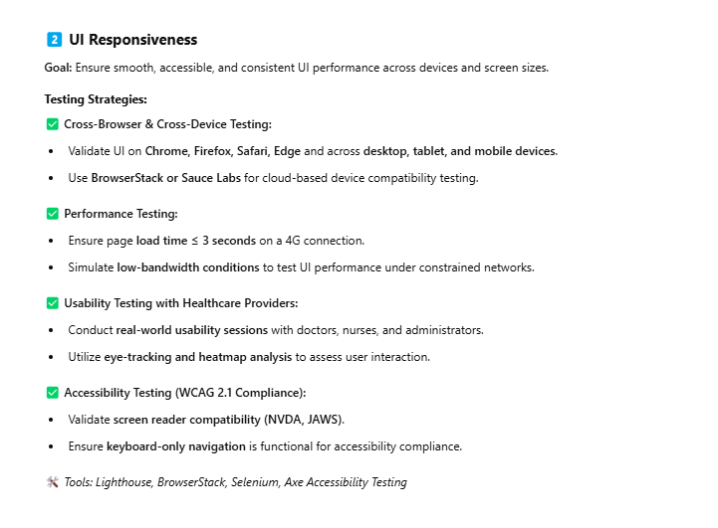

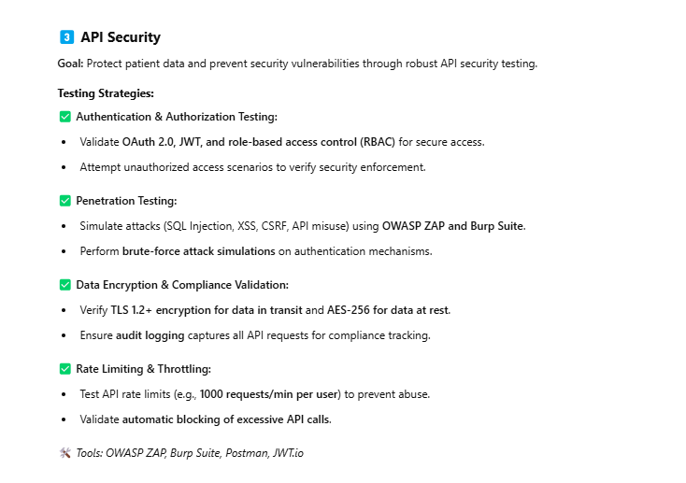

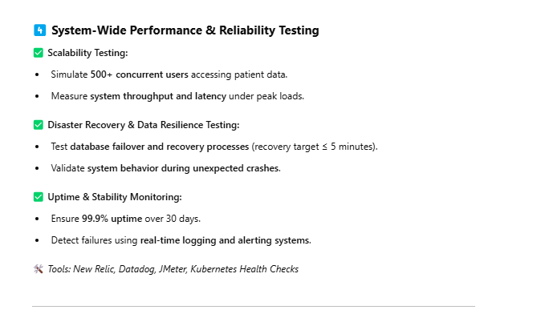

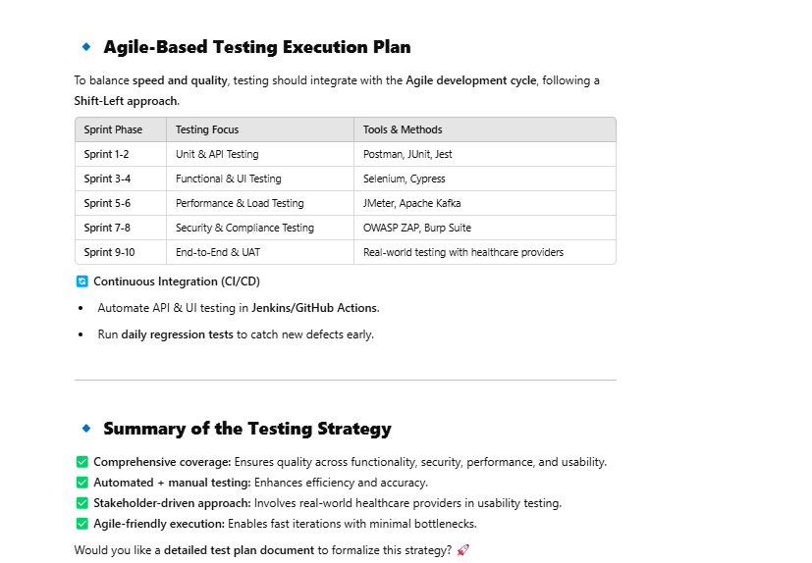

**Step 3:** **Determine testing tools and assess industry standard compliance using   
 ChatGPT**

* 1. Use the following prompt to recommend suitable testing tools, considering factors like compatibility, efficiency, and integration with CI/CD pipelines, as shown in the screenshot below:  
     **Given the project requirements and objectives, please suggest testing tools that would be most suitable. Factors to consider include compatibility with our technology stack, efficiency, and seamless integration with our CI/CD pipelines.**  
       
     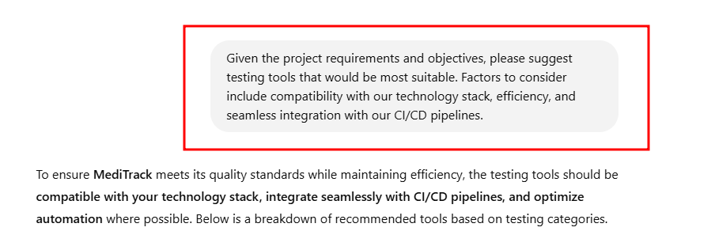

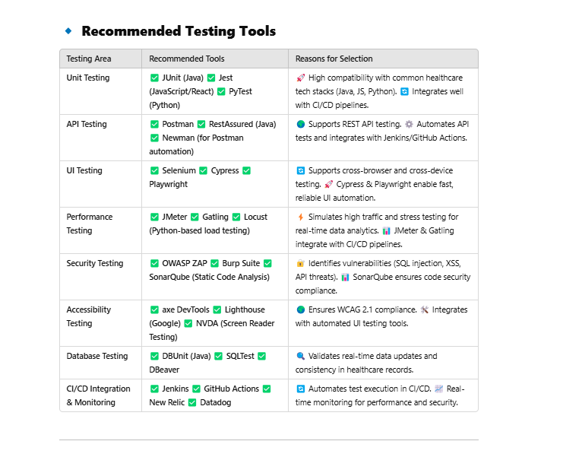

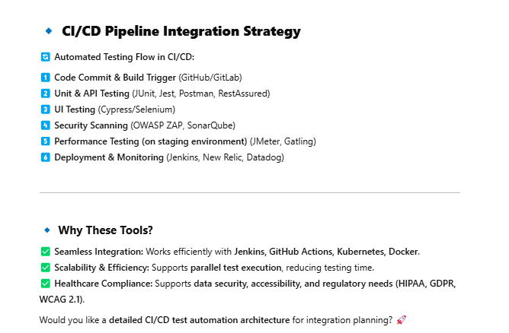

* 1. Assess compliance with industry standards using the following prompt, as shown in the screenshot below:  
     **For our project in healthcare, what industry standards and benchmarks should we adhere to in terms of accessibility, security, and performance? Please provide guidance on ensuring compliance with these standards.**

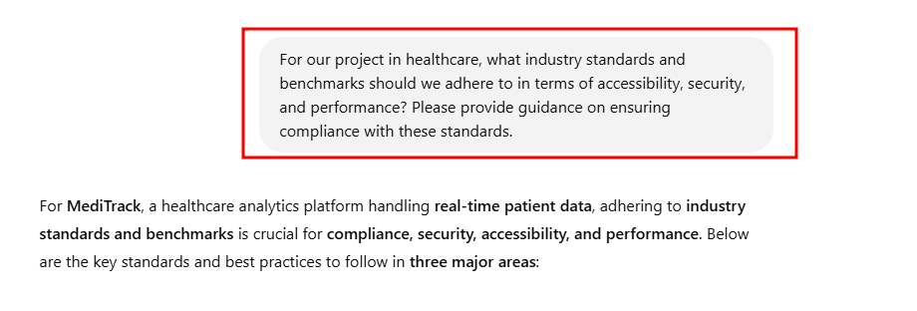

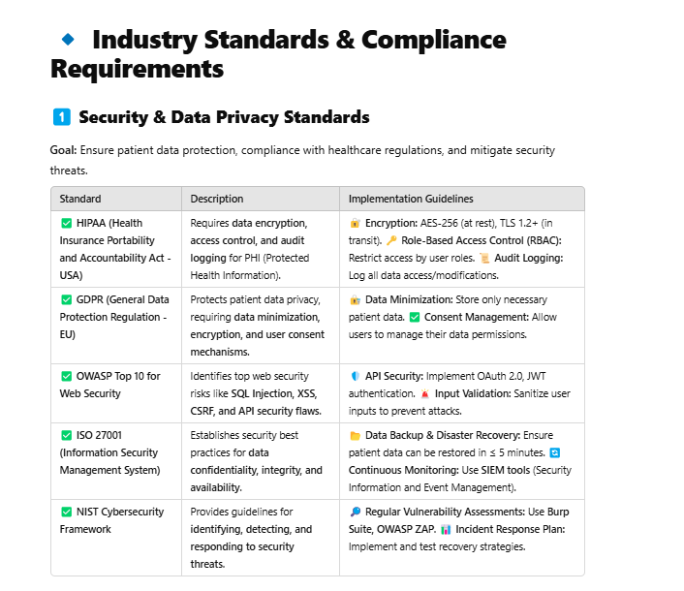

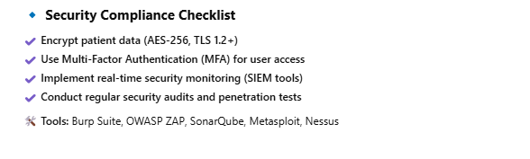

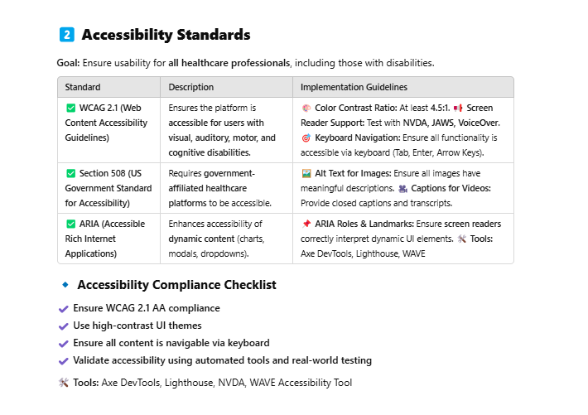

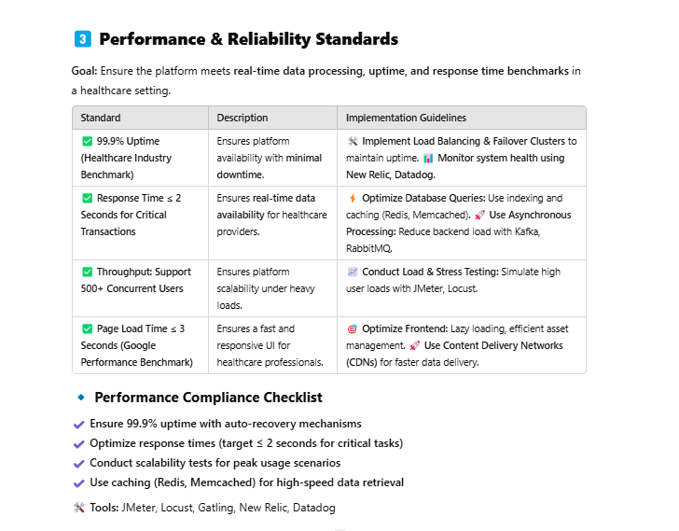

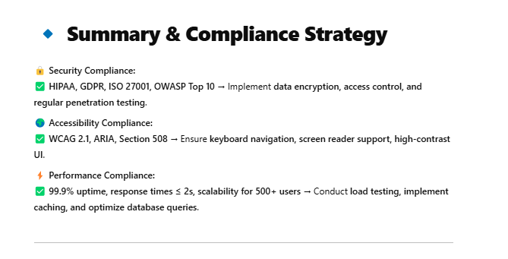  
  
By following these steps, you have successfully optimized test planning for the healthcare analytics platform to ensure enhanced efficiency and compliance with industry standards.